**ADT_Cerner_Soarian Change Attending Physician Requirements**

**Version 1.2**

**Prepared By: Lois Whitley, Art Schwartz, Hope Kaczmarczyk**

**Date: 9/19/2019**

Document Control 3

Resources: 3

Document Version Control 3

1. Introduction 4

1.1 Purpose 4

1.2 Project Scope 4

1.3 Terminology Standards 4

1.3.1 Acronyms 4

1.3.2 Glossary 4

1.4 Document References 4

2. Diagram 5

3. Core Requirements 6

3.1 Cloverleaf Functional Requirements 6

3.2 Cerner FSI Functional Requirements 6

3.3 Non-Functional Requirements 7

3.4 Messaging Protocols 8

3.4.1 Protocol From or to Vendor 8

3.4.2 FSI Comm Server Names 8

4. HL7 Messaging 9

4.1 Messaging Format 9

4.1.1 Segments 9

4.1*.*2 Messaging Event Types 9

4.1*.*3 Cloverleaf Configuration Files 10

4.1.4 Cloverleaf Site Location 10

4.1.5 Cerner FSI Impacted Scripts 10

4.2 Data Transformation Requirements 11

4.3 Sample Message 12

4.3.1 Inbound to Cloverleaf 12

4.3.2 Outbound from Cloverleaf 12

5. Alerts 13

Appendix A: Risks, Concerns & Issues 13

# **Document Control**

## Resources:

Project Distribution List*:*

|  |  |  |
| --- | --- | --- |
| **Name** | **Role** | **Email** |
| Heidi Spriggs | PM / Project Owner/ Sr. Systems Analyst- Revenue Cycle Apps | [Heidi.Spriggs@baycare.org](mailto:Heidi.Spriggs@baycare.org) |
| Art Schwartz | Sr. Integration Analyst | [Art.schwartz@baycare.org](mailto:Art.schwartz@baycare.org) |
| Hope Kaczmarczyk | Sr. Integration Analyst | [Hope.kaczmarczyk@baycare.org](mailto:Hope.kaczmarczyk@baycare.org) |
| Shelly Martin | Sr. Systems Analyst- Documentation/Orders | [Shelly.Martin@baycare.org](mailto:Shelly.Martin@baycare.org) |
| Leeann Terpilowski | Sr. Systems Analyst- Revenue Cycle Apps | [Leeann.Terpilowski@baycare.org](mailto:Leeann.Terpilowski@baycare.org) |
| Earlene J. Meyer | IT Coordinator- CBO | [earlene.meyer@baycare.org](mailto:earlene.meyer@baycare.org)> |
| Lames M. Lalonde | Manager- Siemens App | [James.Lalonde@baycare.org](mailto:James.Lalonde@baycare.org)>; |
| Claudine J. Maly, | Manager- Clinical Systems | [Claudine.Maly@baycare.org](mailto:Claudine.Maly@baycare.org) |
| Tina Cimini | IS Manager- Clinical Facility Support | [tina.cimini@baycare.org](mailto:tina.cimini@baycare.org) |
| Allen R. Wonderling | Sr. Systems Analyst- Ancillary Apps | [Allen.Wonderling@baycare.org](mailto:Allen.Wonderling@baycare.org) |
| Louis Miranda | Sr. Systems Analyst- Diagnostic Clin Apps | [Louis.Miranda@baycare.org](mailto:Louis.Miranda@baycare.org) |
| Ryan M. Kelleher | Sr. Systems Analyst- IS Physician Revenue Cycle Sys | [Ryan.Kelleher@baycare.org](mailto:Ryan.Kelleher@baycare.org) |
| Veretta Worlds | Manager- Management Support Central Business Office | [Veretta.Worlds@baycare.org](mailto:Veretta.Worlds@baycare.org) |
| Ryan Moran | Applications Architect- Revenue Cycle Apps | [Ryan.Moran@baycare.org](mailto:Ryan.Moran@baycare.org)> |
| Mary E. Oswald | Applications Architect- Ancillary Apps | [Mary.Oswald@baycare.org](mailto:Mary.Oswald@baycare.org)>; |

## Document Version Control

|  |  |  |  |
| --- | --- | --- | --- |
| **Version** | **Date** | **Modifier** | **Description** |
| V1.0 | 9/9/2019 | Lois Whitley | Originally Created |
| V1.1 | 9/10/2019 | Art Schwartz | Added CloverLeaf Information |
| V1.2 | 9/17-19/2019 | Hope Kaczmarczyk | Added Cerner Information for Cerner Build for RFC19718 go-live 4/10/19 |
|  |  |  |  |

# 1. Introduction

## 1.1 Purpose

The purpose of this document is to describe the sequence of messages sent when the attending physician is added or changed in Cerner. An ADT message is sent to Soarian to update the attending physician in the patient’s encounter information.

## 1.2 Project Scope

When the attending physician is added or changed in Cerner, an order message (ORM) is sent to Cloverleaf. The interface looks for “Change Attending Physician” in the OBR.4 field of the order message. In Cloverleaf, this message is transformed into an Admission, Discharge Transfer (ADT) message and sent to Soarian as an A08 for consumption.

## 1.3 Terminology Standards

### 1.3.1 Acronyms

ADT – Admission, Discharge, Transfer message

A08 – Update Patient Encounter Information

OBR – Observation Request

ORM – Order message

### 1.3.2 Glossary

Cerner – electronic medical record system

Soarian – current registration system

## 1.4 Document References

Cerner HL7 Specifications: Unit 09o – Order Message Processing Outbound – Cerner Apr 12, 2017

# 2. Diagrams

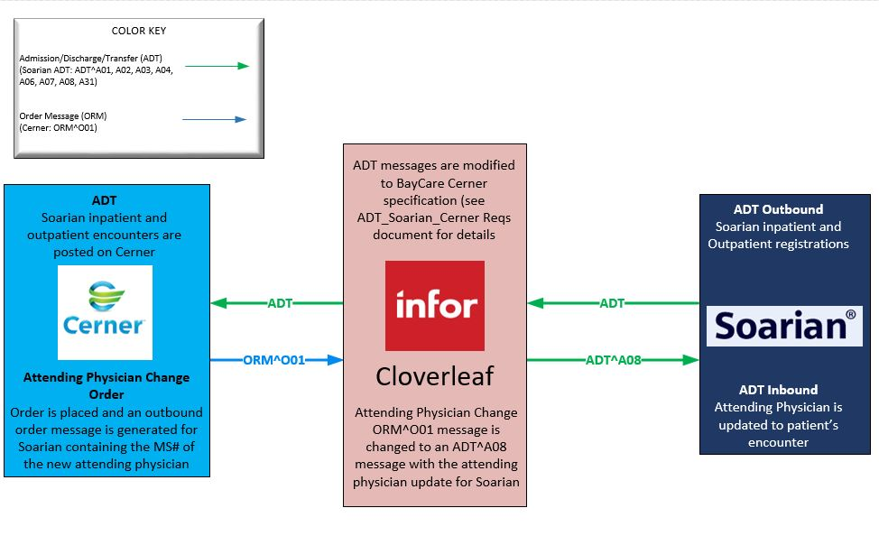

# 3. Core Requirements

## 3.1 Cloverleaf Functional Requirements

The message transformation requirements for the components defined in this section are specified in section 4.2 of this document.

|  |  |  |
| --- | --- | --- |
| **Cloverleaf** | | |
| **Number** | **Requirement Name** | **Description** |
| FR.2019.9.1 | OBR.4 filter | Looks for message = Change Attending Physician |
| FR.2019.9.2 | Receiving application segment | Only MSH, EVN, PID and PV1 are kept |
| FR.2019.9.3 | Translate | Translate done in a proc called tpsCerToSoar; Transforms inbound Cerner ORM change attending order to A08 for Soarian consumption |

## 3.2 Cerner FSI Functional Requirements

|  |  |  |
| --- | --- | --- |
| **Cerner FSI** | | |
| **Number** | **Requirement Name** | **Description** |
| FR.2019.9.1 | Global Suppression Script | **ESO_GET_ORDER_SELECTION** script: Added logic to unsuppress “Change Attending Physician orders” when the order activity type CDF meaning is PHYSCHG. |
| FR.2019.9.2 | Global Route Script | **Route_out** script: Added logic to route ORM messages with an order activity type CDF meaning of PHYSCHG to the ORM_CONSULT_OUT comserver. |
| FR.2019.9.3 | Comserver | **ORM_CONSULT_OUT** (existing comserver): routed “Change Attending Physician orders” outbound on this comserver with “Consult Physician orders”. This comserver uses the Contributor System/Source: INVISION/Invision. |
| FR.2019.9.4 | Mod Object Script | **orm_consult_out** (existing script): Added logic to pull the attending physician’s BayCare MS number from the prsnl_alias table using the physician’s full name selected at order entry. The order activity type CDF meaning must be PHYSCHG and the order entry field meaning must be "ATTENDDOC". |

## 3.3 Non-Functional Requirements

|  |  |  |
| --- | --- | --- |
| **Number** | **Requirement Name** | **Description** |
| NFR.2019.9.1 | Cerner Order Build by the Orders Team | The “Change Attending Physician” order requires:   * an order entry format with an "Attending Provider" order entry field having an oe_field_meaning of "ATTENDDOC". * a new activity type with CDF meaning of PHYSCHG. |

## 3.4 Messaging Protocols

Below are listed the details for the messaging protocols that will be leveraged for this integration. This includes: TCP/IP, FTP, Web Services, etc.

### 3.4.1 Protocol From or to Vendor

|  |  |
| --- | --- |
| FTP |  |
| MLLP Socket Connection (TCP/IP) |  |
| Local File Drop by Midrange Team |  |
| Other | Click here to enter text. |

### 3.4.2 FSI Comm Server Names

|  |  |
| --- | --- |
| Names | ORM_CONSULT_OUT |
|  |  |

# 4. HL7 Messaging

## 4.1 Messaging Format

### 4.1.1 Segments

The segments utilized for this interface are:

MSH

EVN

PID

PV1

*Message Construction Notes:*

*[Square Brackets] – Optional*

*{Curly Brackets} – Repeatable*

*MSH – Message Header*

*EVN – Event segment*

*PID – Patient ID segment*

*PV1 – Patient Visit segment*

### 4.1*.*2 Messaging Event Types

Below are the messages types necessary for this integration

|  |  |
| --- | --- |
| **Event Type** | **Description** |
| O01 | Order message |
| A08 | Update Patient Encounter Information |
|  |  |

### 4.1*.*3 Cloverleaf Configuration Files

For each interface specified in Section 2 of this document, identify the Cloverleaf Configuration Files: Variants, TCL Scripts, Xlates, etc.

### 4.1.4 Cloverleaf Site Location

comes in cerner orders site (6)

goes out on soarian outbound site (23)

### 4.1.5 Cerner FSI Impacted Scripts

**ESO_GET_ORDER_SELECTION** global suppression script

**route_out** global route script

**orm_consult_out** mod object script

## 4.2 Data Transformation Requirements

| **Field Description** | **HL7 Field Loc.** | **Required R/O/C** | **Notes** | **Middleware (CL / FSI / Mule)** |
| --- | --- | --- | --- | --- |
| Sending Application | MSH.3 |  | HNAM inbound; Cerner outbound | CL |
| Sending Facility | MSH.4 |  | Cerner inbound; Facility code outbound | CL |
| Receiving application | MSH.5 |  | Facility ID inbound, SOARF outbound | CL |
| Receiving Facility | MSH.6 |  | BAYCARE inbound | CL |
| Date/Time of Message | MSH.7 |  | Copy | CL |
| Message Type | MSH.9 |  | ORM^O01 inbound; ADT^A08 outbound | CL |
| Message Control ID | MSH.10 |  | Copy | CL |
| Version ID | MSH.12 |  | 2.3 inbound; 2.7 outbound | CL |
| Event Type Code | EVN.1 |  | ADT^A04 from MSH.9 | CL |
| Recorded Date/Time | EVN.2 |  | From MSH-7 | CL |
| Operator ID | EVN.5 |  | CERNER | CL |
| Event Occurred | EVN.6 |  | From MSH-7 | CL |
| Patient ID (External) | PID.2 |  |  | CL |
| Patient ID (Internal) | PID.3 |  |  | CL |
| Patient Name | PID.5 |  |  | CL |
| Date of Birth | PID.7 |  |  | CL |
| Sex | PID.8 |  |  | CL |
| Race | PID.10 |  |  | CL |
| Patient Address | PID.11 |  |  | CL |
| Primary Language | PID.15 |  |  | CL |
| Marital Status | PID.16 |  |  | CL |
| Religion | PID.17 |  |  | CL |
| Patient Account Number | PID.18 |  | copy | CL |
| Ethnic Group | PID.22 |  |  | CL |
| Multiple Birth Indicator | PID.25 |  |  | CL |
| Patient Class | PV1.2 |  |  | CL |
| Assigned Patient Location | PV1.3 |  |  | CL |
| Admission Type | PV1.4 |  |  | CL |
| Attending Doctor | PV1.7 |  | **Cerner**: The orm_consult_out mod object script populates this field with the BayCare MS # of the attending physician entered in the order.  **CloverLeaf**: receives the MS # inbound; removing the “MS”. | FSI/CL |
| Consulting Doctor | PV1.9 |  |  |  |
| Universal Service Provider | OBR.4 |  | Send message if “Change Attending Physician” | CL |
| Ordering Provider | OBR.16 |  |  | CL |
| Results Rpt/Status Change Date/Time | OBR.22 |  |  | CL |
| Diagnostic Service Section ID | OBR.24 |  |  | CL |
| Quantity Timing | OBR.27 |  |  | CL |

## 4.3 Sample Message

### 4.3.1 Inbound to Cloverleaf

MSH|^~\&|HNAM|CERNER|SAH|BAYCARE|20190828060426||ORM^O01|Q5536931695T7529964146|T|2.3||||||8859/1

PID|1|2107064472^^^BayCare MRN^MRN^SOARIAN|2107064472^^^BayCare MRN^MRN^SOARIAN~301934869^^^BayCare CMRN^Community Medical Record Number^SOARIAN||DHHQHSD^YFAALH^^^^^Current~DHHQHSD^YFAALH^^^^^Current||19481001|F||U|GAZAFPA YFARLSXHM^^Djlan [Vhnhsdbgsq^FL^11204^^Home~afah@bjuyjsh.fsq^^^^^^e-mail||||ENG|S|UNK|1006026646^^^BayCare](mailto:Vhnhsdbgsq%5eFL%5e11204%5e%5eHome~afah@bjuyjsh.fsq%5e%5e%5e%5e%5e%5ee-mail||||ENG|S|UNK|1006026646%5e%5e%5eBayCare) FIN^FIN NBR^SOARIAN||||NOH|||0

PV1|1|I|4SW^408^A^SAH^^Bed(s)^SAH|U|||MS068816||MS076552^Ywg^Cjxlh^P^^^^^BayCare Dr Number~MS005992^Ji-Jamjsu^Wjthx^R^^^^^BayCare Dr Number~MS083366^Hojaqhildnj^Fdojimf^C^^^^^BayCare Dr Number|PYD||||EO||Y|MS068816^Phlansjgb^Xlywhih^^^^^^BayCare Dr Number|I||N||||||||||||||||ATE|CD:2353612153||SAH||Discharged|||20190412215100|20190801112500

PV2||Y|^PSYCHOSIS|||||||0||||||||||||CD:438|^^589751

IN1|1|74936961^BH MCR Wellcare^^^BH MCR Wellcare|6311664|Medicare HMO Other|||||BH MCR Wellcare|||20190415000000|||O|DHHQHSD^YFAALH^^^^^Current|1|19481001|GAZAFPA YFARLSXHM^^Djlan [Vhnhsdbgsq^FL^11204^^Home~afah@bjuyjsh.fsq^^^^^^e-mail|||1|||||||||||||N||||||||F||||||623903534J](mailto:Vhnhsdbgsq%5eFL%5e11204%5e%5eHome~afah@bjuyjsh.fsq%5e%5e%5e%5e%5e%5ee-mail|||1|||||||||||||N||||||||F||||||623903534J)

IN2|0||||||||||||||||||||||||623903534J||||||||||||||||||||||||||||||||||||623903534J

ORC|NW|18526157591^HNAM_ORDERID|||20||||20190828060422|B095078^Shipp^Shirley^A^^^^^Username^Personnel^^^Username||MS068816^Phlansjgb^Xlywhih^^^^^^BayCare Dr Number|||20190828060422||||B095078^Shipp^Shirley^A^^^^^Username^Personnel^^^Username

OBR|1|18526157591^HNAM_ORDERID||Change Attending Physician^Change Attending Physician||||||||||||MS068816^Phlansjgb^Xlywhih^^^^^^BayCare Dr Number||||||20190828060422||CD:3733637445|||1^^0^2019070107150

### 4.3.2 Outbound from Cloverleaf

MSH|^~\&|CERNER|U0A5|SOARF||20190412215100||ADT^A08|Q5536931695T7529964146|T|2.7||||||8859/1

EVN|A08|20190412215100|||CERNER|20190412215100||||

PID|||301934869^^^900000^PN|||||||||||||||1006026646^^^504^VCD

PV1|||||||068816^^^^^^^^183^^^^PRN

# 5. Alerts

Are you going to need alerting on this connection?

|  |  |
| --- | --- |
| Yes |  |
| No |  |

If the answer is yes, please complete the table below:

|  |  |  |  |
| --- | --- | --- | --- |
| **Site Name** | **Hours of Support** | **Distribution Group** | **Comments** |
| Soarf_outbound | 24*7*365 | IntegrationTeam@baycare.org | This is an existing connection: If queue depth is greater than 100 for more than 10 minutes, initiate alert and repeat every 30 minutes up to 2 times. |

# Appendix A: Risks, Concerns & Issues

|  |  |  |  |
| --- | --- | --- | --- |
| **Project Name** | |  | |
| **Number** | **Risk/Concern/Issue** | **Comment** | **Mitigation** |
|  |  |  |  |
| RCI.2019.1.0 |  |  |  |
|  |  |  |  |
|  |  |  |  |
|  |  |  |  |

* End of document